Experiment-8
- Implement Router as DHCP server that can serve multiple VLAN's.
Student Name:Parikshit sharma UID:19BCS4520
Branch: CSE Section/GroupIOT/A
Semester: 4 Date of Performance:4/19/2020
Subject Name CN-LAB Subject Code:CSP 291

- Aim/Overview of the practical:

Implement Router as DHCP server that can serve multiple VLAN

Task to be done:
- Implement Router as DHCP server that can serve multiple VLAN's.

- Apparatus(For applied/experimental sciences/materials based labs):cisco packets

4. Algorithm/Flowchart (For programming based labs):no

5. Theme/Interests definition( For creative domains):
DHCP is an application layer protocol used to distribute various network configuration parameters to devices on a TCP/IP network. IP address, subnet masks, default gateways, DNS servers, etc. DHCP employs a client-server architecture. DHCP client is configured to request network parameters from a DHCP server on the network. A DHCP server is configure with a pool of available IP addresses and assigns one of them to the DHCP client.

6. Steps for experiment/practical:
Step 1:Design

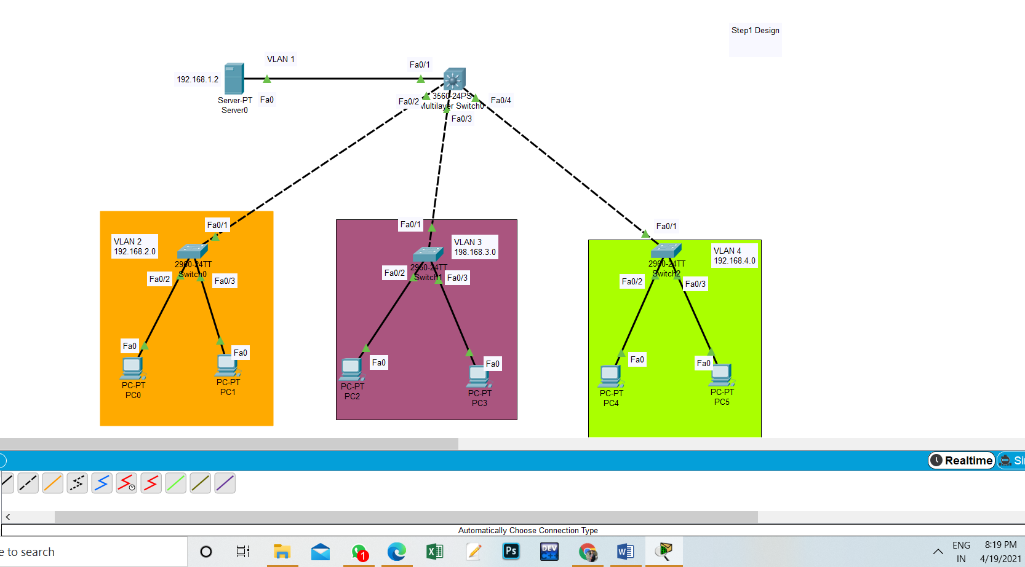
Step2: Create assign the ip/Subnet Mask for Vlan

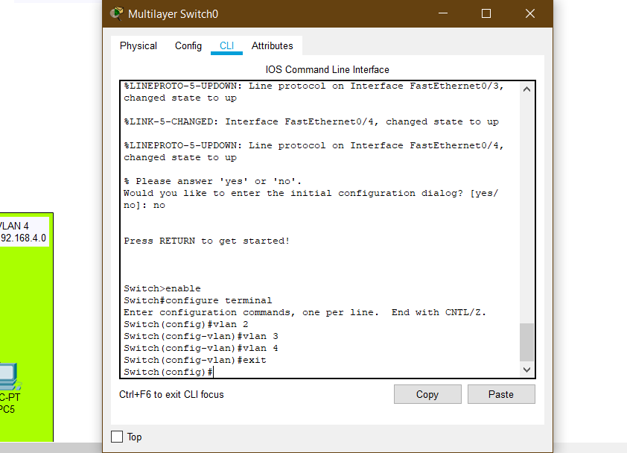
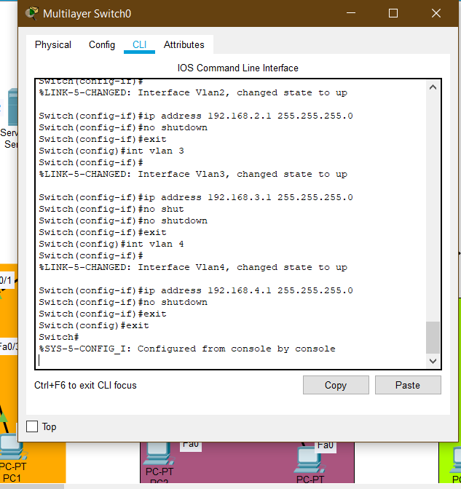
Step 3 Configure DHCP Server
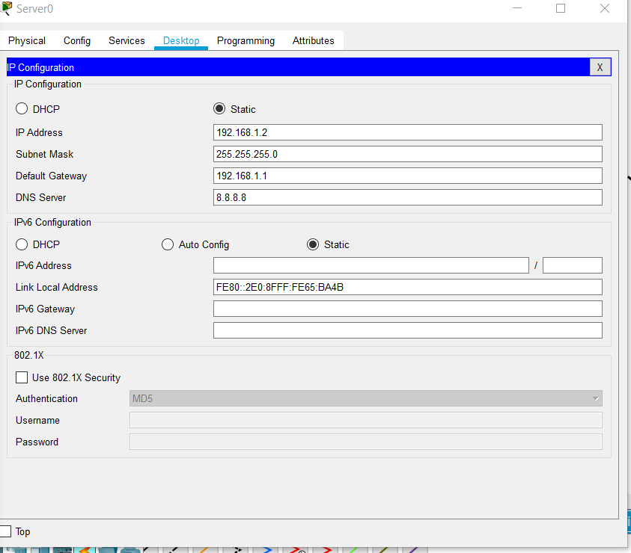
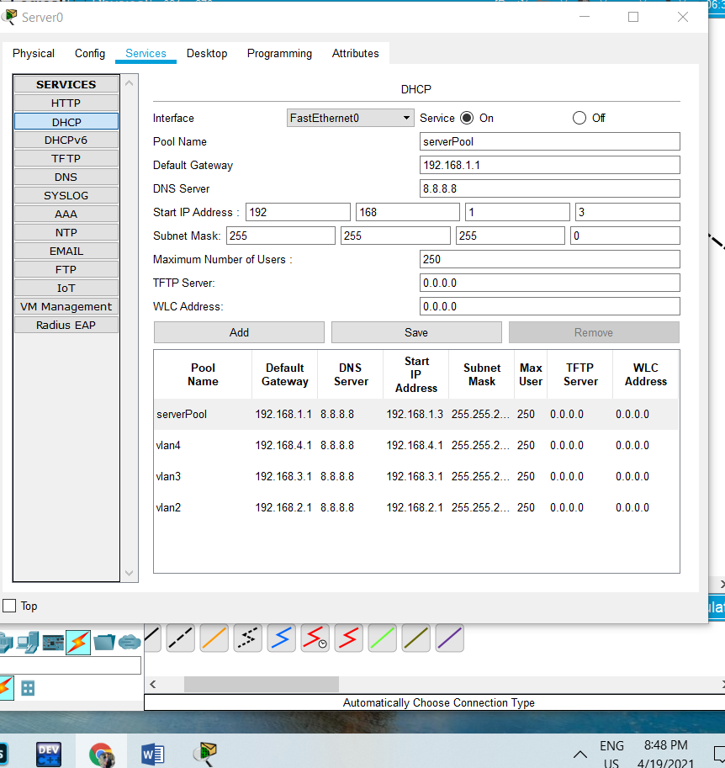
Step 4Configure the mode access/Trunks in Vlan
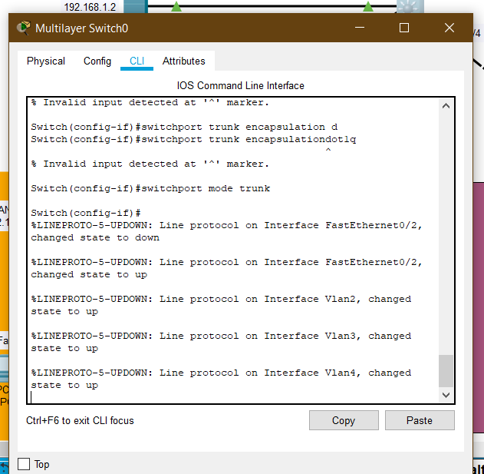
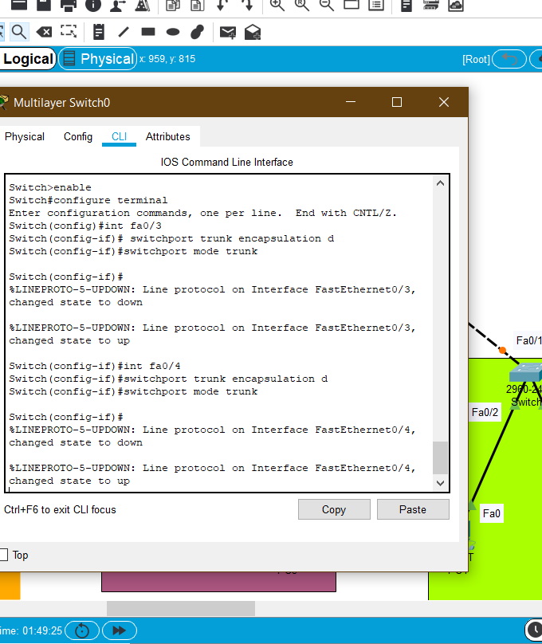
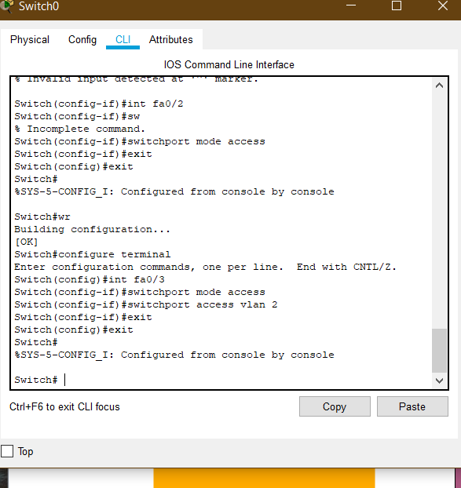
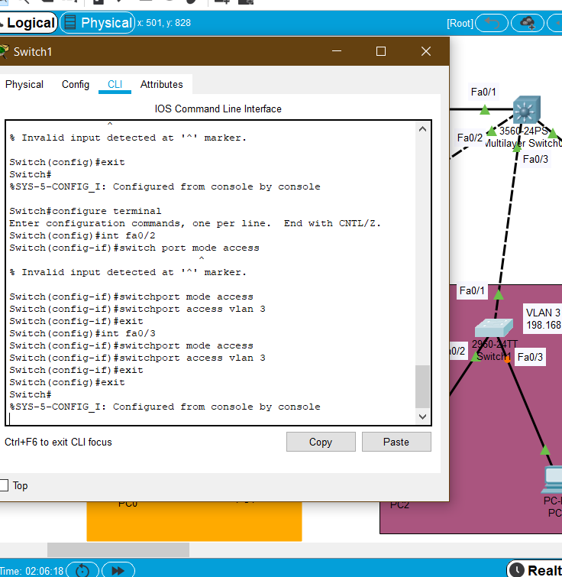
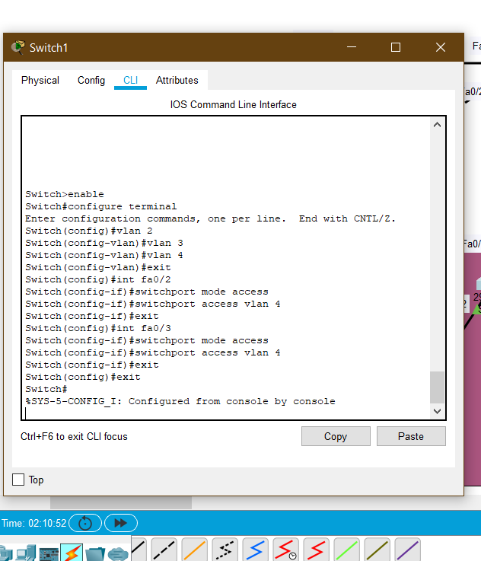
Step 5 Tell pc in vlan where to get ip
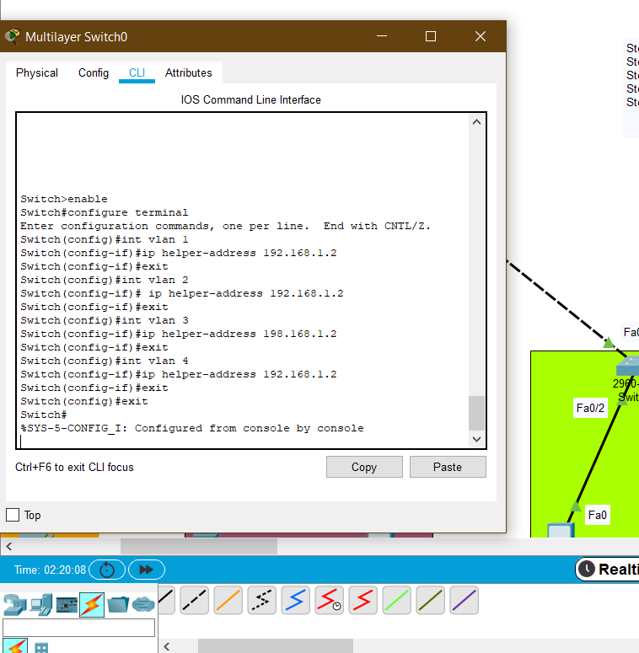

Step 6 routing of multilayer switch
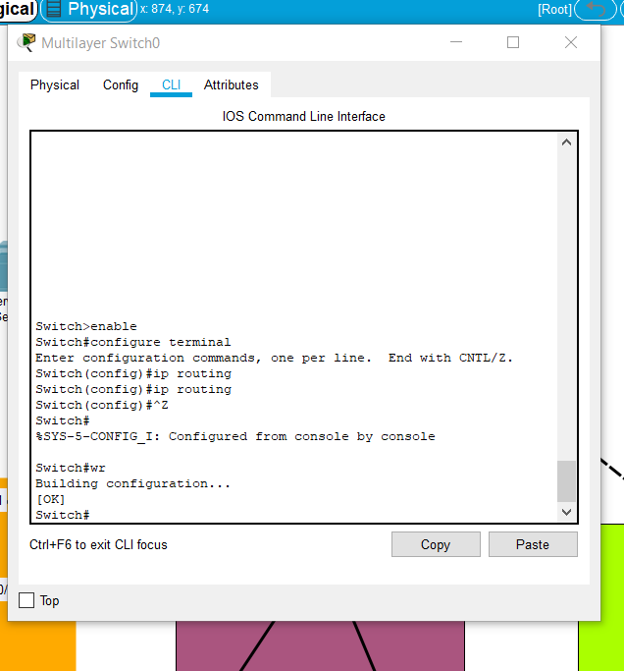

7. Observations/Discussions(For applied/experimental sciences/materials based labs):
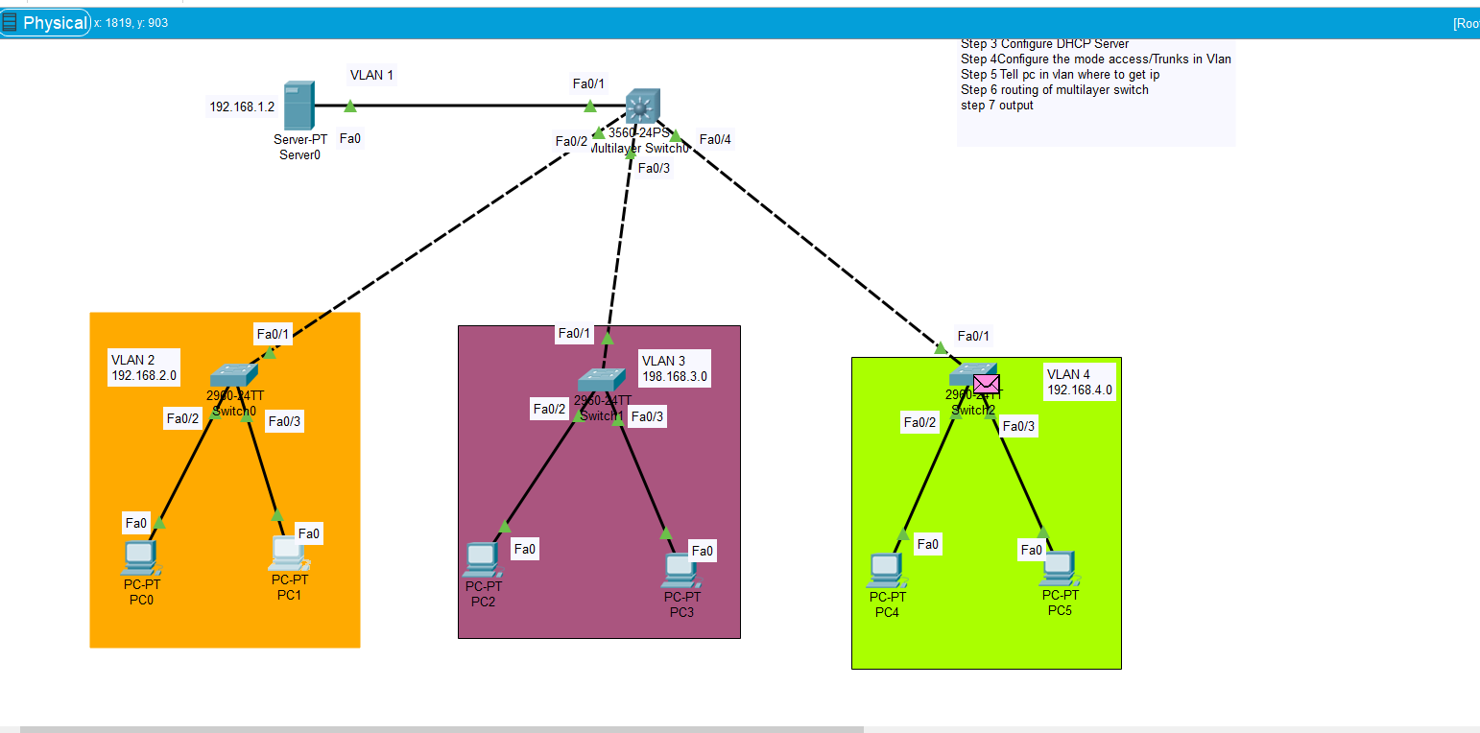

8. Percentage error (if any or applicable):

NO

9. Calculations/ Chemical Reactions / Theorems /Formulas used etc :

NO

10. Result/Output/Writing Summary:

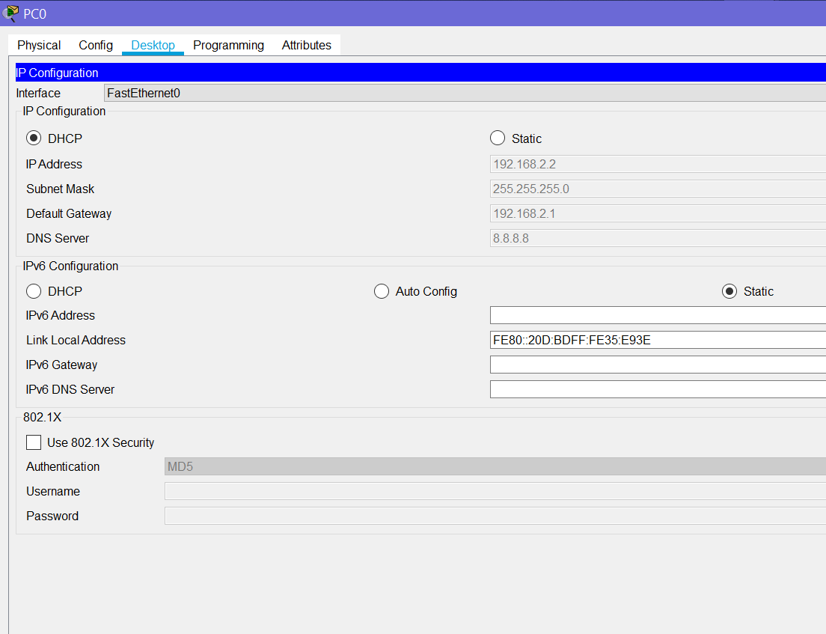

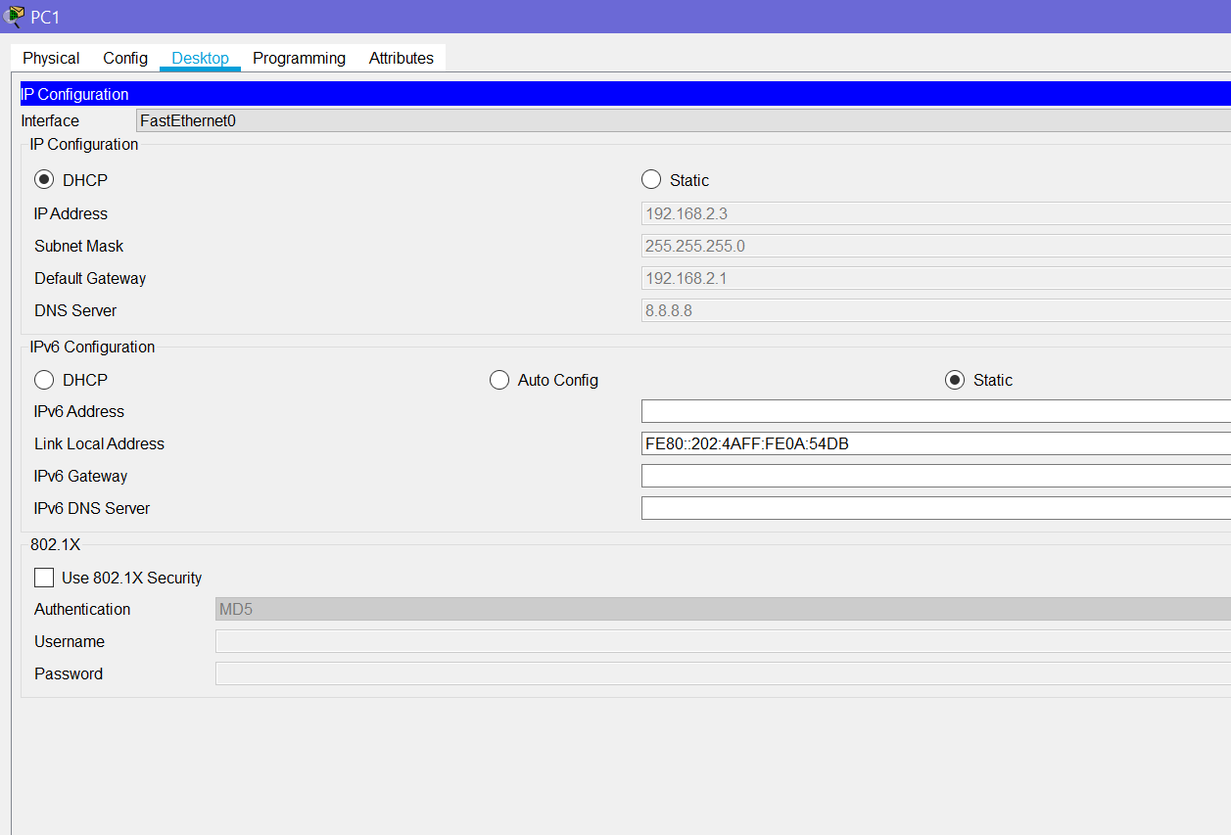

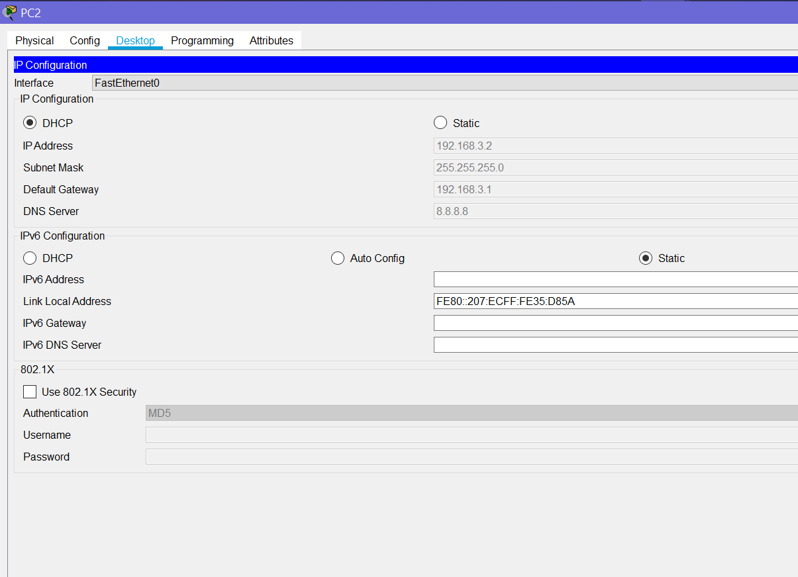
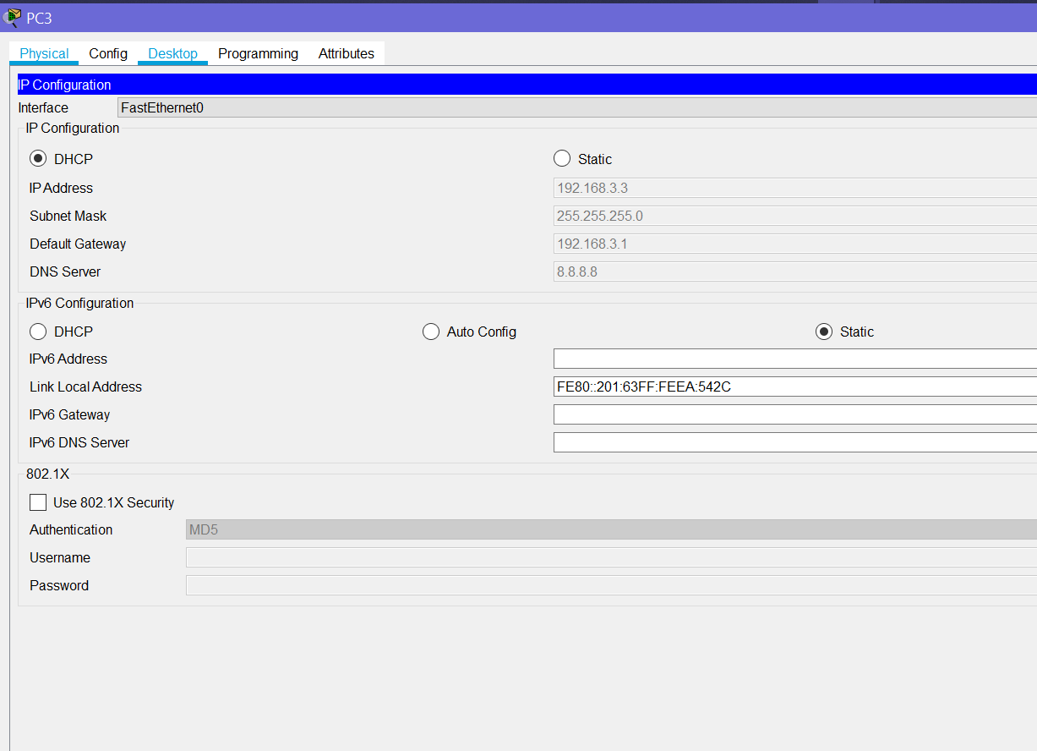
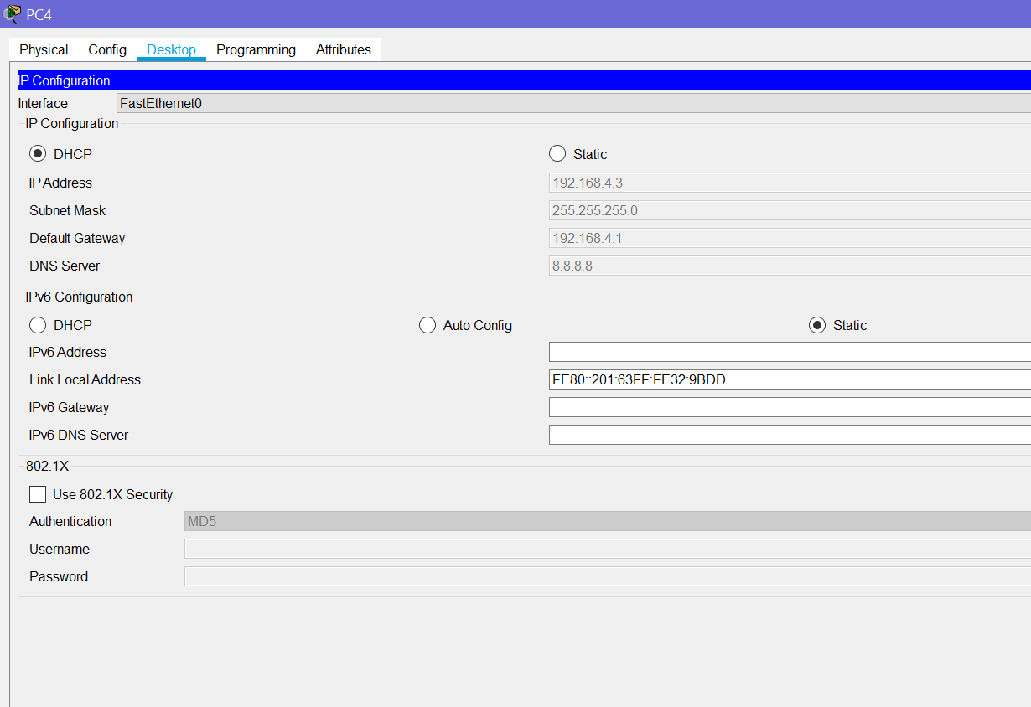
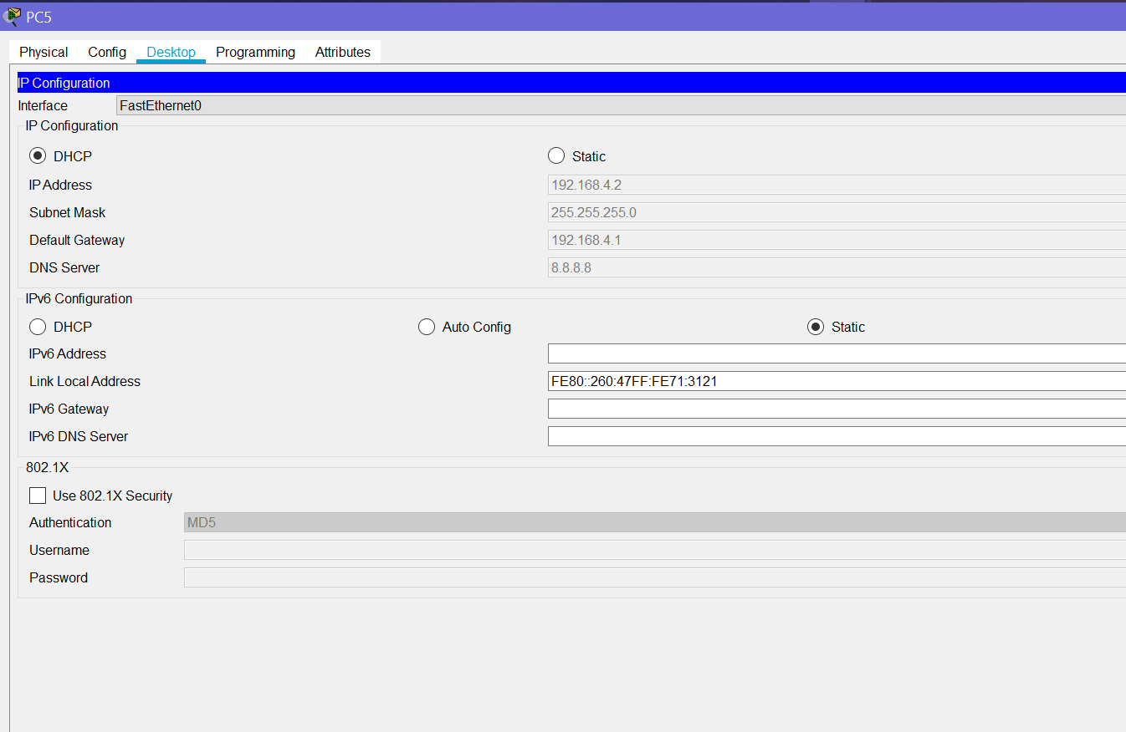

11. Graphs (If Any): Image /Soft copy of graph paper to be attached here

NO

Learning outcomes (What I have learnt):
1. Learned about DHCP.
2. Error finding in network.
3. Learned about the multiport switch.
4. Learned about using multiport and DHCP network together.
5. Learned about routing of multilayer switch.

Evaluation Grid (To be created as per the SOP and Assessment guidelines by the faculty):
Sr. No. | Parameters | Marks Obtained | Maximum Marks
1.
2.
3.

